SQL ASSIGNMENT-1

**BY: DHANASREE.S**

1. **Do we have actors in the actor table that share the full name and if yes display those shared names.**

Ans: Yes we have actors with shared names. The first name is SUSAN and the last name is DAVIS. So, we have two shared names in the table.

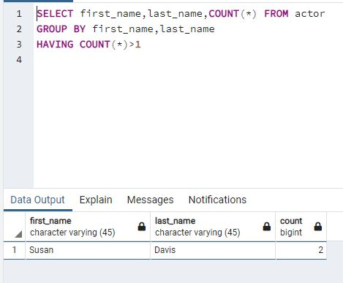

1. **Return the customer IDs of customers who have spent at least $110 with the staff member who has an ID of 2.**

Ans: The customer id 187 and 148 has spent at least $110 with staff id 2.

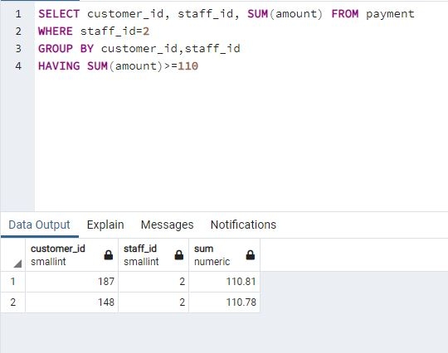

1. **How many films begin with the letter J?**

Ans: There are 20 movies that start with letter J.

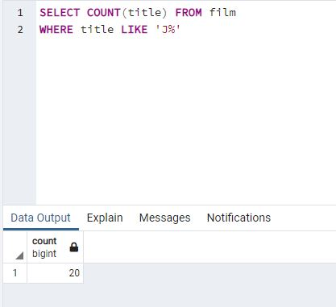

1. **What customer has the highest customer ID number whose name starts with an 'E' and has an address ID lower than 500?**

Ans: Customer EDDIE has the highest customer id and name starting with E.

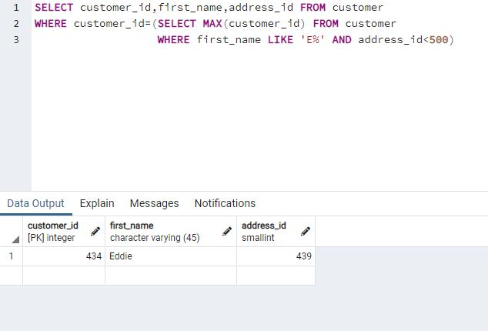

1. **How many films have the word Truman somewhere in the title?**

Ans: Five movies have the word TRUMAN in the title

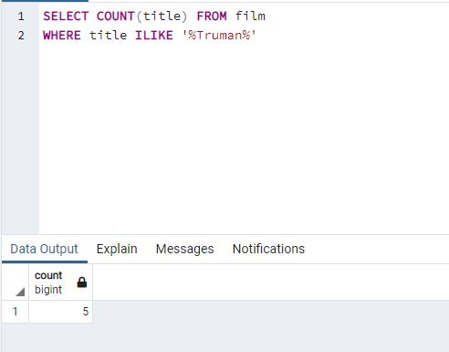

1. **Display the total amount payed by all customers in the payment table.**

Ans: The total amount payed by all the customers is the sum of amount column.

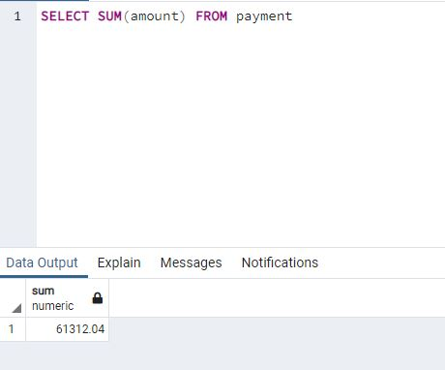

1. **Display the total amount payed by each customer in the payment table.**

Ans: We total the sum of amount and group by customer_id.

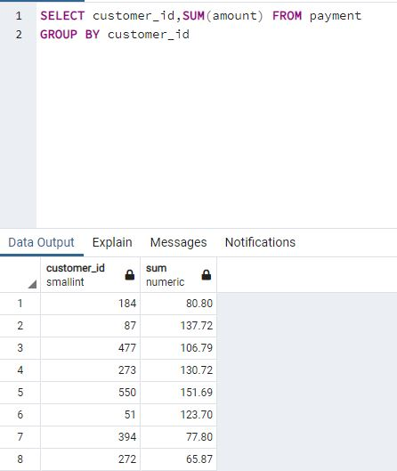

1. **What is the highest total payment done?**

Ans: The highest total payment is by customer id 148 and the payment done is 211.55

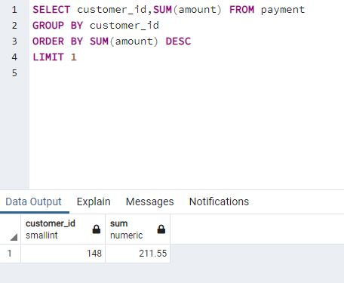

1. **Which customers have not rented any movies so far?**

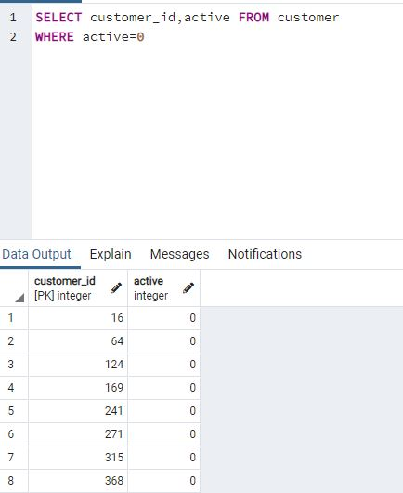

1. **How many payment transactions were greater than $5.00?**

Ans: 3618 transactions where greater than $5.00

